Azure AI services help developers and organizations rapidly create intelligent, cutting-edge, market-ready, and responsible applications with out-of-the-box and prebuilt and customizable APIs and models. Example applications include natural language processing for conversations, search, monitoring, translation, speech, vision, and decision-making.

Azure computer vision and Vision studio is conected

Azure AI Studio: <https://ai.azure.com/>

Azure AI Services:

* Language
* Vision
* Speech
* Documents
* Decision Support

Azure AI Service for Computer vision:

**Reference link:**

<https://learn.microsoft.com/en-us/training/modules/analyze-images-computer-vision/?wt.mc_id=learnlive-20220307A%2C3reg_15525_webpage_reactor>

Analyze images with the computer vision service

<https://ai.azure.com/?tid=91749299-4db7-4de5-8e67-b355e5ee9e2a>

Azure AI Vision Studio: <https://portal.vision.cognitive.azure.com/demo/image-captioning>

Learn via: <https://microsoftlearning.github.io/mslearnfundamentals/Instructions/Labs/03-image-analysis.html>

Create a resource on azure portal on computer vision to connect with Vision studio

* On the **Getting started with Vision** landing page, select the **Image analysis** tab and then select the **Add captions to images** tile.
* use the same image to perform **Dense captioning**. Return to the **Vision Studio** home page, and as you did before, select the **Image analysis** tab, then select the **Dense captioning** tile.
* A person and a child in a store

  Description automatically generated
* Next try extract common tags on Image Analysis tab

Review the list of tags extracted from the image and the confidence score for each in the detected attributes panel. Here the confidence score is the likelihood that the text for the detected attribute describes what is actually in the image. Notice in the list of tags that it includes not only objects, but actions, such as shopping, selling, and standing.

Detect objects:

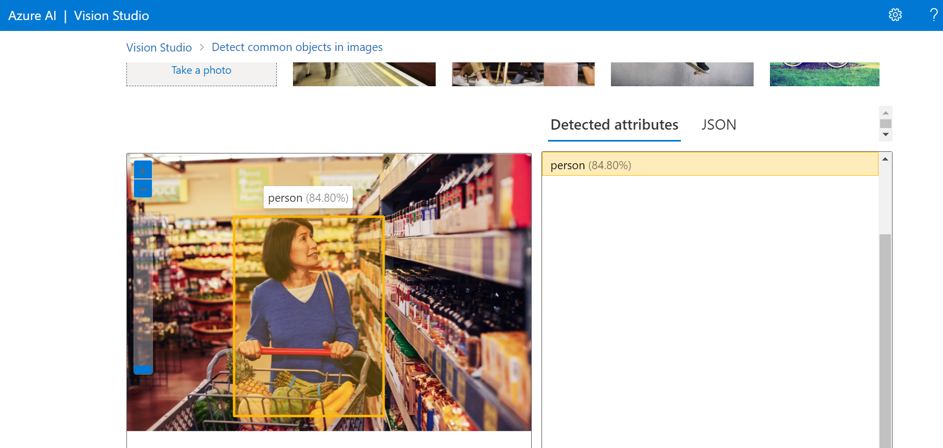

***Thank you***